CASHMERE SCHOOL DISTRICT NO. 222 CHELAN COUNTY, WASHINGTON

NOTICE OF MEETING TO ADOPT 2018-19 BUDGET AND CONDUCT PUBLIC

HEARING

**NOTICE** is hereby given, pursuant to RCW 28A.505.050 and RCW 28A.505.060, that the Board of Directors (the "Board") of Cashmere School District No. 222, Chelan County, Washington (the "District") will hold a special meeting on July 9th, 2018, commencing at 6:00 PM in the Cashmere District Board Room, located at 210 S. Division Street, Cashmere, Washington. The meeting is called for the purpose of fixing and adopting the budget of the District for the ensuing 2018-19 fiscal year. Prior to adoption of the 2018-19 budget, the Board will hold a hearing for the purpose of receiving comments from the public on the 2018- 19 budget. Any person may appear at the hearing and be heard for or against any part of the 2018-19 budget, the four year budget plan, or any proposed changes to uses of enrichment funding under RCW 28A.505.240. Upon conclusion of the hearing, the Board shall fix and determine the appropriation from each fund contained in the 2018-19 budget and shall, by resolution, adopt the 2018-19 budget, the four year budget plan summary, and the four-year enrollment projection.

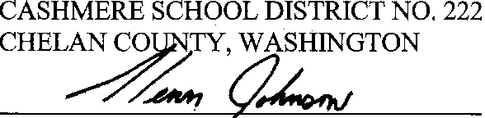

Superintendent and secretary to the Board of Directors